URL: <http://www.gaocdental.com/>

GAOC takes pride in having an ultra-modern dental center in the Philippines, offering an extremely-advanced technology in oral diagnostic and surgical procedures, dental implantology and jaw reconstruction. From conventional check-ups to the most complicated oral rehabilitation procedures, GAOC is fully equipped to handle any dental contingency at an affordable price. The GAOC Team is highly trained to ensure patient’s comfort and satisfaction with the finest quality of dentistry in terms of the latest techniques and technology available. Well versed in all areas of dental medicine, our team will happily share our knowledge about the advances in implant and cosmetic dentistry with you to help select the form of treatment that will restore your oral health, give you the smile you desire, and discuss the responsibilities for the daily care of your teeth.

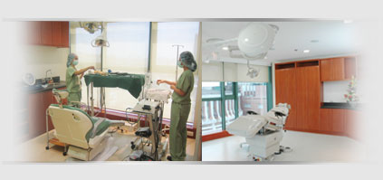

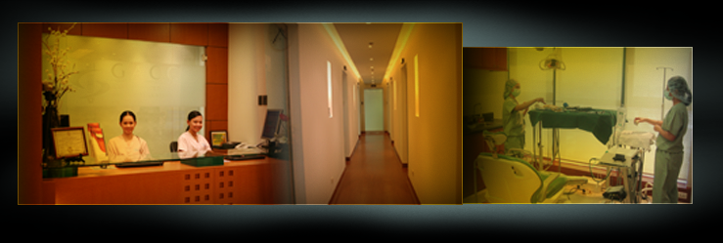



**Doctor’s credentials:**

Dr. Steve Mark Gan

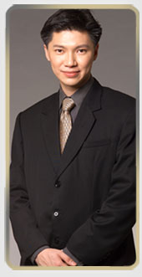A passion for learning and people has led Dr. Gan to establish GAOC. Educated in the United States, Dr. Gan has had extensive training and experience in the fields of dental medicine with expertise honed on world-class standards, particularly, in oral implantology and maxillo-facial surgery. His academic credentials, his commitment and dedication to his profession and his results-oriented approach to his work are behind his 100% success rate in the wisdom teeth surgical procedures he has performed & 98.5% success rate on dental implants.

He received his dental degree in 1993 from The University of the East in Manila, Philippines.

He then underwent a one-year oral surgery externship program at the University of the Philippines-Philippine General Hospital, before taking an advanced prosthodontic residency at the University of Southern California in Los Angeles from 1995 to 1998. Dr. Gan has developed his skills in prosthodontic implant training from the University of California in 1996 and continued his implant surgery training at the West Coast Surgery Center for Osseointegration in Los Angeles, USA. Since then, he has worked in an exclusive dental surgery practice, providing the best dental care to adults and children.

Dr. Gan is a fellow/member of:

* Philippine Academy of Implant Dentistry (*president-elect 2007*)
* Academy of Osseointegration (*committee member*)
* International Congress of Oral Implantologist
* American Society of Osseointegration
* American College of Oral Implantology

Always doing his best to be updated on the latest surgical techniques, he regularly attends international conferences and meetings.

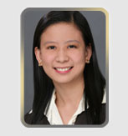

CHERRIE ANNE A. CRUZ, DMD  
Specialization: Orthodontics  
  
By graduating top of her class at Centro Escolar University, having a string of multi-disciplinary honors for her extra-curricular involvement, and more recently, receiving her preceptorship certificate from the Philippine Academy of Orthodontics, Dr. Cherrie Anne Cruz has cemented her dental profession with remarkable flair for excellence and an even brighter future as a distinguished expert in the field of dentistry. As a business partner and operations manager for GAOC– one of the most successful dental centers in Asia today – she works with cyclonic energy, making sure that GAOC’s promise of impressive service to all its patients is faithfully kept.

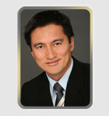

GERALD S. BUENAVENTURA, DMD  
Specialization: Orthodontics  
  
Our attending dentist’s story is a tale of triumph and inspiration. Reared into an atmosphere of unparalleled focus and a passion for excellence since his childhood days, Dr. Gerry Buenaventura devoted his young life into the practice of dento-facial orthopedics, making him one of the most popular in the field of orthodontics in the industry today. After graduating from the University of the East in 1989, he pursued further studies in orthodontics from the University of Munich and enhanced his skills through further studies at the Universite de Rennes in France. He his currently G.A.O.C.’s visiting orthodontist and continues to engage in private practice, attending to his legions of satisfied patients.

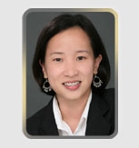

KIM T. COELI, DMD  
Specialization: Pediatric Dentistry  
  
Against the grand spectacle of commercial practice and moneyed recognition, Dr. Kim Coeli stands as one of the few competent and compassionate dental practitioners who shun the glare of glory and prefers to work silently at the sidelines, conducting a number of gratuitous dental missions to depressed areas and public schools. Having completed her dental degree from the University of the East in 2001, she currently works as an Associate Dentist at the Children’s Dental Center and devotes her time as a visiting pediatric practitioner at G.A.O.C. Her passion for positive action is only matched with her remarkable compassion for children, as she continuously shares her expertise in oral prophylaxis, tooth extractions, fluoride treatment and oral health awareness to elementary students nationwide.

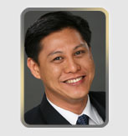

DENNIS P. ANDIGAN, DMD  
Specialization: Endodontics  
  
He reached for a place in the Philippine dental industry by being one of the most dynamic young practitioners in the country today. Highly skilled in the practice of general dentistry, which now includes, among his vast array of specializations, endodontics, orthodontics, and dental implantology, Dr. Dennis Andigan is G.A.O.C.’s visiting endodontist. An academically gifted student, he landed at the top one percent in the 1994 licensure examinations for dentists, after graduating with flying colors from the University of the East’s College of Dentistry. He doggedly pursued post graduate training, specializing in basic and advanced endodontic clinical procedures – making him one of the most stellar root canal therapists in his field of expertise.

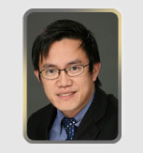

SONNY H. BURIAS, DMD  
Specialization: Cosmetic Dentistry  
  
His is a life of action and bold ventures with people and industry, of a uniquely personal triumph in search for excellence, of hopes raised for progress in his field of specialization. For Dr. Sonny Burias, G.A.O.C.’s visiting cosmetic dentist, aggressiveness and vision reined pre-eminent and is, in great part, the base for his outstanding accomplishments as one of the fastest-rising dentists, specializing in Cosmetic dentistry. A graduate from the University of the East in 1992, he worked as a dental consultant at the Kerr Dental Company Sybron in the Philippines, which exposed him to the inner workings of composite and esthetic restorative materials. He was the founding member of the Philippine Academy of Esthetic Dentistry and lends his services as a lecturer for esthetic and precise tooth preparation. Dedicated to the pursuit of excellence in his craft, he is involved in a continuing education program at the University of California in Los Angeles on restorative dentistry and prosthodontics.

**Services:**

* [Dental Implants](http://www.gaocdental.com/dental-implants)
* [Wisdom Tooth Removal](http://www.gaocdental.com/wisdom-tooth-removal)
* [Oral and Maxillofacial Surgery](http://www.gaocdental.com/oral-and-maxillofacial-surgery)
* [Restorative Dentistry](http://www.gaocdental.com/restorative-dentistry)
* [Pediatric Dentistry](http://www.gaocdental.com/pediatric-dentistry)
* [Cosmetic Dentistry](http://www.gaocdental.com/cosmetic-dentistry)
* [Teeth Whitening](http://www.gaocdental.com/teeth-whitening)
* [Bone Grafting](http://www.gaocdental.com/bone-grafting)
* [Prosthodontics](http://www.gaocdental.com/prosthodontics)
* [Other Special Procedures](http://www.gaocdental.com/other-special-procedures)

**Apicoectomy (Root-End Resection)**

**Endodontic**

**Orthodontic treatment**

**Contact us:**

**Medical Plaza Makati**  
Suite 1204-1206 & Suite 1708-1709  
Amorsolo St. corner Dela Rosa St.  
Makati City 1229  
(632) 843-9112

Trunk Line: (632) 843-GAOC (4262)  
E-mail: [info@gaocdental.com](mailto:info@gaocdental.com)